A
Project Report
Learning Report
On

“ Traffic Violation Detection System”
Submitted to
CMR ENGINEERING COLLEGE
(UGC AUTONOMOUS)
Affiliated to JNTU HYDERABAD
In Partial Fulfillment of the requirements for the Award of Degree of
BACHELOR OF TECHNOLOGY
in
Computer Science and Engineering (Data Science)
Submitted By:
K.VISHAL 238R1A67G1
G.MAHALAKSHMI 238R1A67E7
P.SHIVA 238R1A67H6
P.GAYATRI 248R5A6714

Under the esteemed guidance of
Mrs.T.VIRAJITHA

(Assistant Professor, CSE-Data Science)

Department of Computer Science & Engineering(Data Science)

CMR ENGINEERING COLLEGE
(UGC AUTONOMOUS)
Approved by AICTE, Permanent Affiliation to JNTUH, Accredited by NBA and NAAC Kandlakoya(V), MedchalDist-501 401

2025-2026

CMR ENGINEERING COLLEGE
(UGC AUTONOMOUS)

Approved by AICTE, Permanent Affiliation to JNTUH, Accredited by NBA and
NAAC Kandlakoya(V), MedchalDist-501 401

2025-2026
Department of Computer Science & Engineering(Data Science)

CERTIFICATE

This is to certify that the project entitled “Traffic Violation Detection System” is a bonafide work carried out by:
K.VISHAL - 238R1A67G1
G.MAHALAKSHMI - 238R1A67E7
P.SHIVA - 238R1A67H6
P.GAYATRI - 248R5A6714

In partial fulfillment of the requirement for the award of the degree of BACHELOR OF TECHNOLOGY in COMPUTER SCIENCE AND ENGINEERING (Data Science) from
CMR Engineering College, affiliated to JNTU, Hyderabad, under our guidance and supervision. The results presented in this project have been verified and are found to be satisfactory. The results embodied in this project have not been submitted to any other university for the award of any other degree or diploma.

INTERNAL GUIDE HEAD OF DEPARTMENT
Mrs.T.Virajitha Dr.M.Laxmaiah
Assistant Professor Professor & HOD
CSE-DS,CMREC CSE-DS, CMREC

DECLARATION

This is to certify that the work reported in the present project entitled “Traffic Violation Detection System” is a record of bonafide work done by us in the Department of Computer Science and Engineering (Data Science), CMR Engineering College, JNTU Hyderabad. The reports are based on the project work done entirely by us and not copied from any other source. We submit our project for further development by any interested students who share similar interests to improve the project in the future. The results embodied in this project report have not been submitted to any other University or Institute for the award of any degree or diploma to the best of our knowledge and belief.

K.VISHAL - 238R1A67G1
G.MAHALAKS - 238R1A67E7
P.SHIVA - 238R1A67H6
P.GAYATRI - 248R5A6714

III

ACKNOWLEDGMENT

We are extremely grateful to Dr. A. Srinivasula Reddy, Principal and Dr. M. Laxmaiah, HOD, Department of CSE-DS, CMR Engineering College for their constant support.

We are extremely thankful to Mrs. T. Virajitha, Assistant Professor, Internal Guide, Department of CSE (Data Science), for her constant guidance, encouragement and moral support throughout the project.

We will be failing in duty if we do not acknowledge with grateful thanks to the authors of the references and other literatures referred in this Project.

We express our thanks to all staff members and friends for all the help and co-ordination extended in bringing out this project successfully in time.

Finally, we are very much thankful to our parents who guided us for every step.

K.VISHAL - 238R1A67G1
G.MAHALAKS - 238R1A67E7
P.SHIVA - 238R1A67H6
P.GAYATRI - 248R5A6714

ABSTRACT

In recent years, the exponential growth in the number of vehicles on roads has led to a significant increase in traffic congestion, accidents, and violations of traffic regulations. Ensuring proper traffic management and law enforcement has become a critical challenge for authorities, especially in densely populated urban areas. Traditional systems of monitoring traffic—such as manual observation by traffic police or static surveillance cameras—are time-consuming, inefficient, and prone to human error. To overcome these limitations, this project presents an Artificial Intelligence (AI)-based Traffic Violation Detection System that utilizes computer vision and deep learning techniques to automatically detect, record, and report traffic violations in real time.

The detected violation data, including the vehicle number, time, location, and type of violation, is automatically stored in a database for further analysis or integration with official traffic enforcement systems. This automation eliminates the need for manual monitoring and ensures that every violation is captured with high accuracy and consistency. Additionally, the system can be connected to government or municipal databases to automatically issue electronic fines (e-challans) to offenders, thereby improving the transparency and efficiency of traffic law enforcement.

This AI-driven approach not only enhances the speed and precision of traffic violation detection but also provides valuable analytics for traffic authorities to assess accident-prone zones and improve road safety measures. The proposed system demonstrates the potential of combining Artificial Intelligence, Computer Vision, and Internet of Things (IoT) technologies to build smarter, safer, and more sustainable urban transportation infrastructures. Ultimately, it contributes to the realization of Smart City initiatives by promoting automation, reducing human effort, and fostering adherence to road safety regulations.

CONTENTS

TOPIC PAGE.NO

ABSTRACT V
LIST OF FIGURE VII

1.INTRODUCTION 1
Overview
Problem Statement

2. LITERATURESURVEY 2

3.EXISTING SYSTEM 3
Overview of Existing system
Disadvantages of Existing system

4. PROPOSED SYSTEM 5
Overview of Proposed system
Advantages of proposed system

5. UML Diagrams 10
Use Case Diagram
Class Diagram
Activity Diagram
Sequence Diagram

6. SYSTEM REQUIREMENT SPECIFICATION 14
Software Requirements
Hardware Requirements

7.SOURCE CODE 17

8.RESULT 23

9.CONCLUSION AND FUTURE SCOPE 25

10. REFERENCES 26

LIST OF FIGURES

FIG.NO | DESCRIPTION | PAGENO
5.1 | Use Case Diagram | 10
5.2 | Class Diagram | 11
5.3 | Activity Diagram | 12
5.4 | Sequence Diagram | 13

INTRODUCTION

Overview
With the rapid increase in urbanization and the exponential growth in the number of vehicles, traffic management and road safety have become major challenges worldwide. Traditional traffic enforcement systems largely depend on manual monitoring by traffic police or semi-automated tools such as speed sensors and static cameras. These systems are often inefficient, error-prone, and incapable of handling the scale and complexity of modern traffic networks.
To address these issues, Artificial Intelligence (AI) and Computer Vision have emerged as powerful technologies capable of automating traffic surveillance and rule enforcement. The AI-Based Traffic Violation Detection System leverages deep learning algorithms—such as YOLO (You Only Look Once) and Convolutional Neural Networks (CNNs)—to detect, track, and analyze vehicles in real time. It identifies violations such as red-light jumping, helmet non-compliance, overspeeding, and lane violations, and automatically logs the details like vehicle number, violation type, time, and location into a secure database.
The system also incorporates Automatic Number Plate Recognition (ANPR) technology using OCR (Optical Character Recognition) to extract vehicle registration numbers for offender identification. This information can be directly integrated with government transport databases to automatically generate electronic challans (e-challans). As a result, the system ensures accurate, consistent, and real-time enforcement of traffic rules, reducing the dependency on human monitoring and improving overall road discipline.
This project demonstrates the integration of AI, Deep Learning, and IoT to create a scalable and efficient traffic management framework aligned with the Smart City vision. By automating violation detection and data analysis, it not only reduces human effort but also provides valuable insights for urban planning, accident prevention, and public safety improvement.

Problem Statement

Traffic rule violations such as overspeeding, red-light jumping, and helmet non-compliance are among the primary causes of road accidents and fatalities. Traditional enforcement methods are manual, time-consuming, and prone to human error, leading to inefficiencies in traffic law enforcement. In many developing cities, monitoring large road networks is nearly impossible due to limited manpower and infrastructure.
Existing systems, like speed guns and static cameras, are limited to specific types of violations, require manual verification, and often fail under poor lighting or weather conditions. Moreover, these systems lack integration with vehicle registration databases, causing delays in offender identification and penalty issuance. Consequently, many violations go unnoticed or unpunished, leading to increased road accidents, traffic congestion, and loss of human lives.

Literature Survey

2.1 Vehicle / Object Detection & Tracking
- Detecting vehicles (cars, bikes, trucks) is a foundational step. Older works used feature-based or motion-based methods; more recent works use deep-learning object detectors (e.g., YOLOv8, SSD, Faster-R-CNN). For example: a study uses YOLO for object detection in violation contexts.
- Tracking (to follow the vehicle’s path) is important for detecting movement across frames (e.g., red-light jump, wrong lane). Methods like Kalman filtering, SORT or DeepSORT are used. In one paper: Kalman filter is used for vehicle tracking.
2.2 Violation Classification
- Once vehicles are detected/tracked, the next step is to classify whether a violation has occurred. Common violation types in literature include: red-light running, overspeeding, wrong-lane/illegal overtaking, helmet/seatbelt non-compliance, triple-riding.
- For red-light detection: one paper uses object detection to detect vehicles and signals (red/yellow/green), then analyzes vehicle crossing of stop-line.
- For helmet/seatbelt detection: A recent work uses few-shot data sampling and YOLOv8 for real-time helmet violation detection.
- For speed violation: A survey discusses methods (radar, laser, sensor, and computer vision).

2.3 License Plate Recognition / Identification
- Many works incorporate automatic license plate recognition (ALPR / ANPR) to identify the offender’s vehicle. For example, the report by Dahal et al. mentions using plate segmentation and character recognition after object detection/tracking.
2.4 Integration & Real-Time Considerations
- Real-time processing is a frequent mention: the system must process live video, detect & log violations quickly. Some studies focus on speed/latency of detection pipelines. For instance, the “Intelligent Vehicle Violation Detection” paper reports average detection accuracy and speed. `
- Human-Computer Interaction: some works incorporate GUI and interface for traffic managers.

Existing System

The existing traffic violation detection systems predominantly rely on manual observation and semi-automated technologies such as speed sensors, radar guns, and conventional CCTV cameras. In most cities, traffic rule enforcement is primarily carried out by traffic police officers stationed at intersections or highways. These officers manually observe the movement of vehicles and record violations such as signal jumping, helmet or seatbelt absence, and wrong-lane driving. In some cases, handheld cameras or smartphones are used to capture images or videos of the violating vehicles, which are then used as evidence for issuing fines. However, this manual approach is not only labor-intensive but also time-consuming and prone to human error, especially during heavy traffic hours when continuous monitoring becomes extremely challenging.

To overcome some of these drawbacks, sensor-based systems were introduced. These systems use devices such as speed guns, loop detectors, and red-light cameras that automatically capture images of vehicles violating speed or signal rules. For instance, radar-based systems detect a vehicle’s speed and trigger a camera if it exceeds the permitted limit, while inductive loop sensors embedded in the road surface trigger cameras when a vehicle crosses the stop line during a red light. Although these systems reduce manual effort, they are still limited to specific violation types and often require human verification for final penalty processing.

Overall, the existing systems are reactive rather than proactive. They can record violations but cannot analyze them intelligently or provide immediate alerts. Their functionality is confined to specific violations, and their performance deteriorates under poor weather conditions, varying lighting, or high traffic density. Moreover, most existing systems lack integration with vehicle databases, which means the process of identifying violators and issuing fines is often delayed and requires human intervention. Therefore, there is a growing need for an intelligent, automated, and data-driven solution that can operate efficiently, detect multiple types of violations, and provide real-time decision-making capabilities.

Disadvantages of Existing System

- Human Dependency: Most systems rely heavily on manual monitoring by traffic personnel, leading to fatigue, inconsistency, and potential human bias.
- Limited Detection Scope: Traditional systems can usually detect only one type of violation (e.g., speed or red-light jumping) and cannot identify multiple types simultaneously.
- Low Accuracy: Manual observation and non-intelligent camera systems are prone to errors in identifying vehicles and violations, especially in crowded or low-visibility conditions.
- Delayed Response: Evidence verification, license plate identification, and fine generation are slow processes, often taking days to complete.
- High Maintenance and Cost: Sensor-based systems require expensive installation and regular maintenance, which is difficult to scale across large urban areas.
- Lack of Real-Time Monitoring: Current systems do not provide instant alerts or automatic violation reporting to enforcement authorities.
- Poor Integration: There is limited or no connection between the monitoring systems and government vehicle registration databases for automatic fine generation.
- Environmental Limitations: Existing systems often fail under adverse weather conditions such as rain, fog, or at night, leading to inaccurate or missed detections.
- Data Management Issues: Manual handling of violation data increases the risk of loss, manipulation, or corruption of records.
- Scalability Challenges: Implementing these systems citywide requires extensive manpower and infrastructure, making them inefficient for large-scale deployment.

Proposed System

The proposed system uses Artificial Intelligence (AI) and Computer Vision to automatically detect and record traffic violations in real time. It captures live video from CCTV or IP cameras and processes each frame using deep learning models such as YOLO to identify vehicles, helmets, lanes, and traffic signals. The system can detect multiple violations like overspeeding, red-light jumping, and helmet or seatbelt non-compliance. Once a violation is detected, it automatically extracts the vehicle’s license plate using Automatic Number Plate Recognition (ANPR) and stores the details—such as vehicle number, time, and location—in a database. This data can be linked to transport department records for automatic fine generation. The proposed system reduces human intervention, increases accuracy, and enables efficient, real-time enforcement of traffic laws, supporting the development of smart and safe transportation systems.
Key Features:
Multi-Violation Detection:
Capable of identifying various types of traffic violations such as overspeeding, red-light jumping, helmet or seatbelt non-compliance, lane violations, and wrong-way driving.
Real-Time Processing:
Employs AI-based video analytics to analyze live CCTV feeds and detect violations instantly, eliminating the need for manual intervention or delay.
Automatic Number Plate Recognition (ANPR):
Uses advanced image processing and OCR (Optical Character Recognition) techniques to extract vehicle registration numbers from captured images for offender identification.
Integration with Traffic Databases:
Seamlessly connects with government or transport department databases to enable automatic fine (e-challan) generation and violation tracking.
High-Accuracy Detection:
Utilizes state-of-the-art deep learning models such as YOLOv8 and CNN architectures to ensure robust and reliable detection, even in complex or crowded traffic environments.
Data Storage and Reporting:
Every detected violation is recorded in a secure database along with metadata such as time, date, location, and violation type for evidence management and analytical reporting.
Scalability and Automation:
Designed for deployment across multiple intersections and can be scaled to cover entire cities with minimal human supervision.
Environmental Adaptability:
Incorporates advanced image enhancement and preprocessing techniques to maintain detection accuracy under challenging environmental conditions such as poor lighting, rain, fog, or nighttime operation.
Real-Time Alerts and Notifications:
Provides instant notifications and dashboard updates to traffic authorities upon detection of violations, enabling faster response and enforcement actions.

Technological Framework:

1. Hardware Components
CCTV / IP Cameras: Installed at intersections or highways to capture high-definition video streams for analysis.
Computation Unit / Edge Device: A local processing unit (GPU-enabled system or edge AI device like NVIDIA Jetson) for real-time inference.
Networking Equipment: Routers and servers for connecting cameras to the central monitoring station and database.
Storage Devices: Local or cloud-based storage for archiving detected violations and images/videos.
2. AI and Deep Learning Frameworks:

Object Detection:
Model: YOLOv8 / YOLOv5 / SSD / Faster R-CNN
Frameworks: PyTorch or TensorFlow
Function: Detect vehicles, helmets, lanes, and pedestrians in each video frame.

Traffic Signal and Lane Detection:
Libraries: OpenCV, Image Processing Filters, Hough Transform
Function: Detect red/green lights, stop lines, and lane boundaries.

Helmet and Seatbelt Detection:
Approach: Train custom YOLO model to classify riders with and without helmets/seatbelts.

Speed Estimation:
Technique: Calculate vehicle displacement between frames using frame rate and reference distance markers.

License Plate Recognition (ANPR):
Libraries: OpenCV, EasyOCR, Tesseract OCR
Function: Detect, segment, and recognize license plate characters for identification.

Data Analytics and Reporting:
Tools: Pandas, Matplotlib, Seaborn, or Power BI for visualization and statistical analysis of traffic data.

3. Workflow of the Proposed System:

Video Input: Live video is captured from CCTV or IP cameras.

Frame Extraction and Preprocessing: Each frame is enhanced for clarity, noise removal, and resizing.

Object Detection: AI model (YOLO/CNN) detects vehicles, helmets, lanes, and signals.

Violation Identification: Based on movement patterns, color of signal, or missing protective gear, the system classifies a violation.

License Plate Recognition: ANPR extracts the license plate from the detected vehicle.

Data Logging: The system logs violation details into the database with timestamp, type, and vehicle number.

Reporting and Alerts: The system can generate alerts, reports, or automatic challans for the violators.

Advantages of Proposed System

- Automated Violation Detection:
The system automatically detects traffic rule violations such as red-light jumping, overspeeding, lane violations, and helmet or seatbelt non-compliance without human supervision.
This eliminates human error and reduces dependency on traffic police.
- Real-Time Monitoring and Alerts:
Provides instant detection and notification of traffic violations.
Traffic authorities can respond immediately to violations, improving enforcement efficiency.
- High Accuracy and Reliability:
Utilizes deep learning models (like YOLO and CNN) for object detection, ensuring accurate recognition of vehicles, traffic signals, and safety compliance even in crowded or complex traffic scenarios.
Reduces false positives and missed violations compared to manual monitoring.
- Multi-Violation Detection Capability:
Unlike traditional systems, it can simultaneously detect multiple types of violations from a single video feed.
This makes enforcement more comprehensive and effective.
- Automatic License Plate Recognition (ANPR):
Captures the license plate of violating vehicles and extracts details using OCR.
Enables automatic identification of offenders for e-challan generation without manual intervention.
- Efficient Data Storage and Reporting:
Stores violation records in a centralized database, including vehicle number, violation type, timestamp, and location.
Supports statistical analysis to identify high-risk zones and peak violation times.
- Scalable and Cost-Effective:
Can be deployed across multiple intersections or highways with minimal human resources.
Reduces the cost of hiring and managing large numbers of traffic personnel.
- Environmental Adaptability:
Works effectively under different lighting and weather conditions (day/night, rain, fog) through image preprocessing and enhancement techniques.

- Integration with Smart City Infrastructure:
Can be linked to government databases for automatic fine generation and real-time monitoring dashboards.
Supports a connected and intelligent traffic management ecosystem.
- Enhanced Road Safety:
By providing consistent enforcement and real-time alerts, it discourages rule violations.
Contributes to reducing accidents and improving overall traffic discipline.
- Time and Resource Saving:
Minimizes the need for manual surveillance, evidence collection, and verification.
Speeds up the process of violation detection, reporting, and fine issuance.
- Data-Driven Insights:
Enables traffic authorities to perform analytics on collected data to identify traffic trends, accident-prone areas, and habitual violators.
Supports informed decision-making and strategic planning for traffic management.

UML DIAGRAMS

Use Case Diagram:

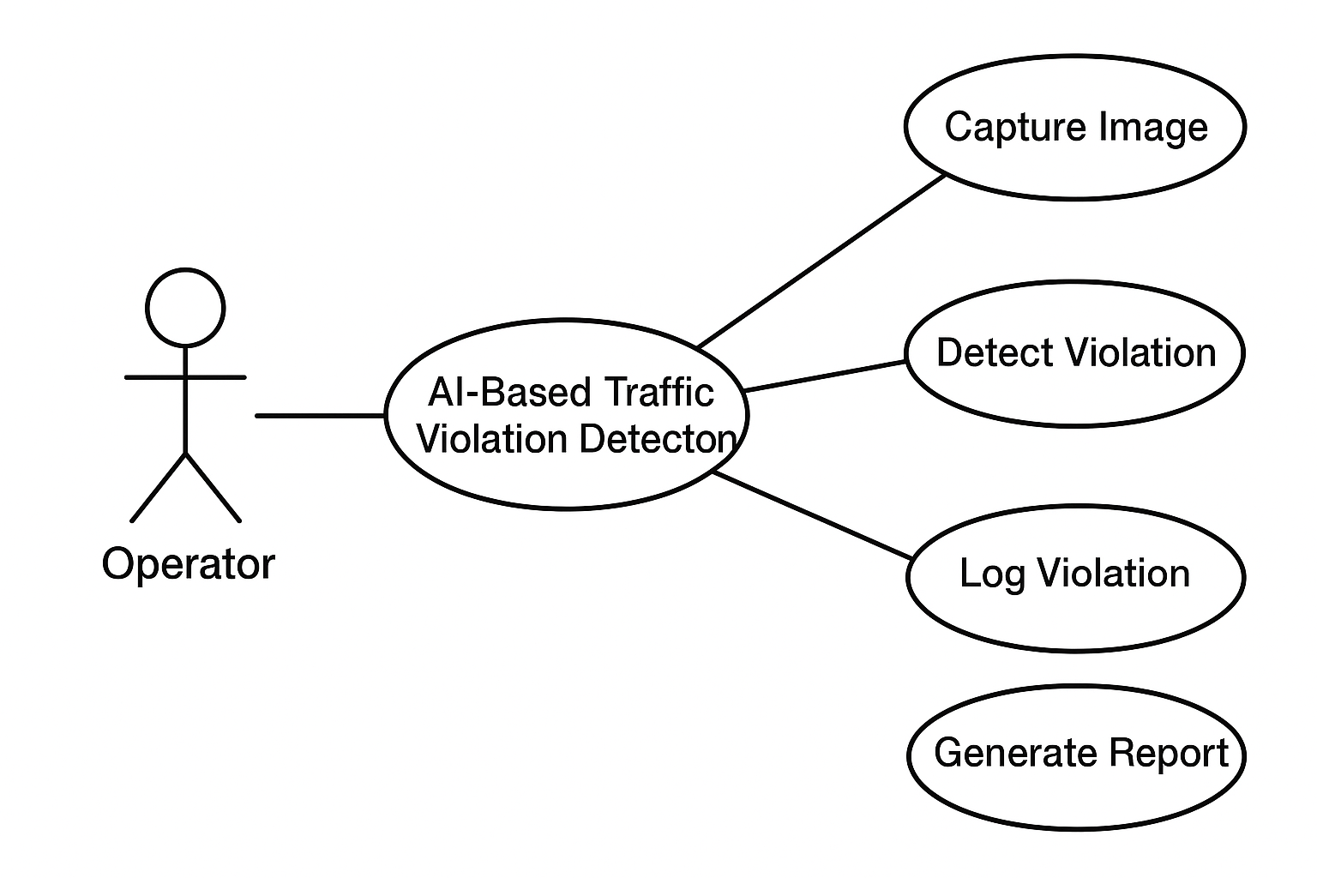

Fig-5.1:Use Case Diagram

Class Diagram:

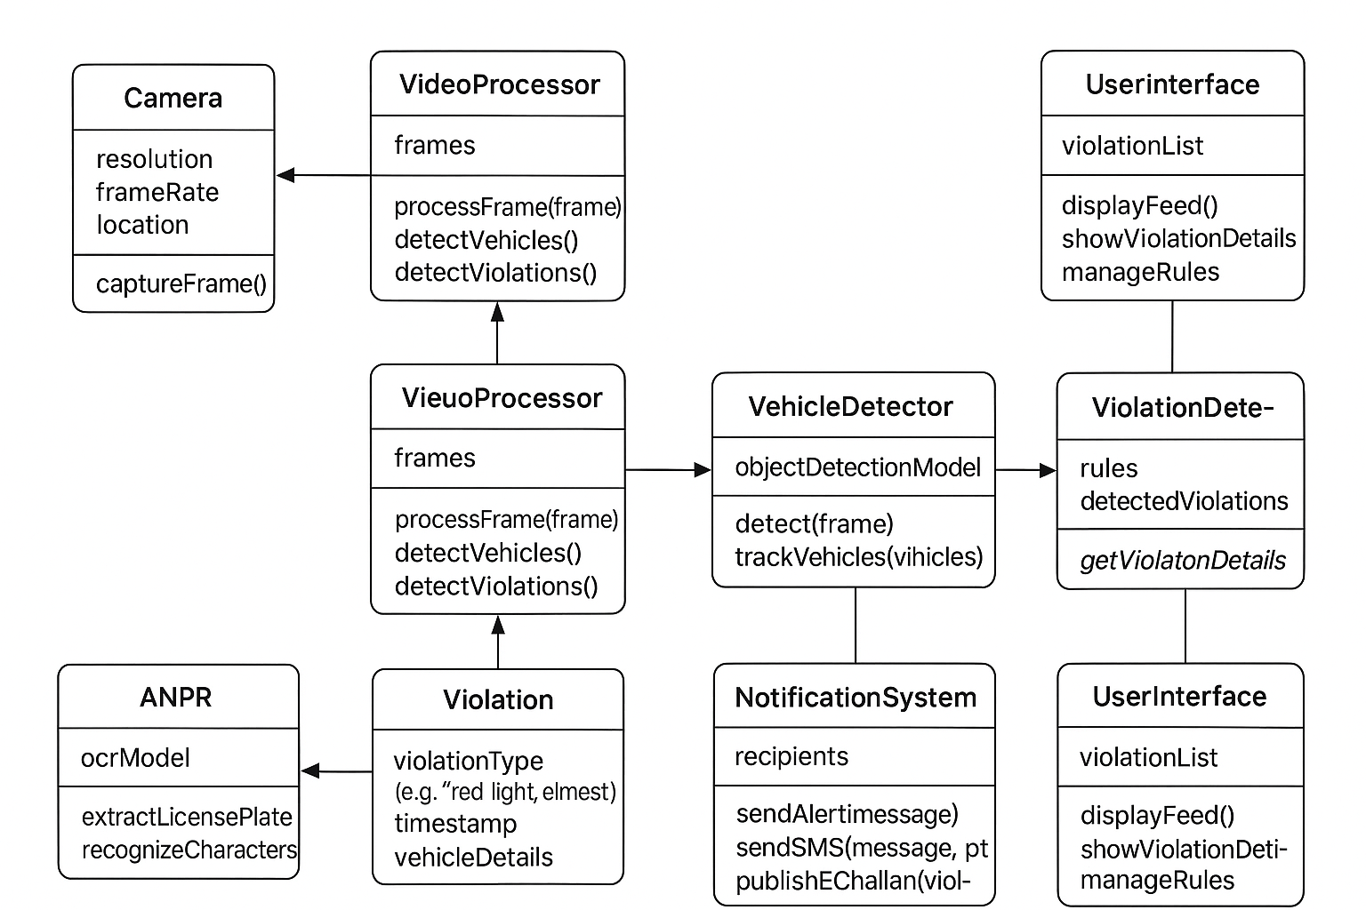

Fig-5.2:Class Diagram

Activity Diagram:

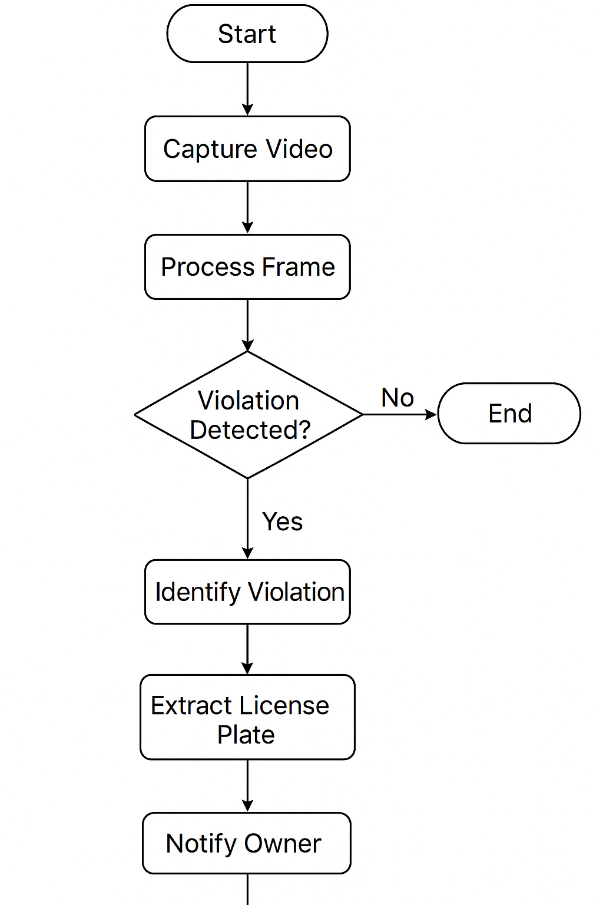

Fig-5.3:Activity Diagram

Sequence diagram:

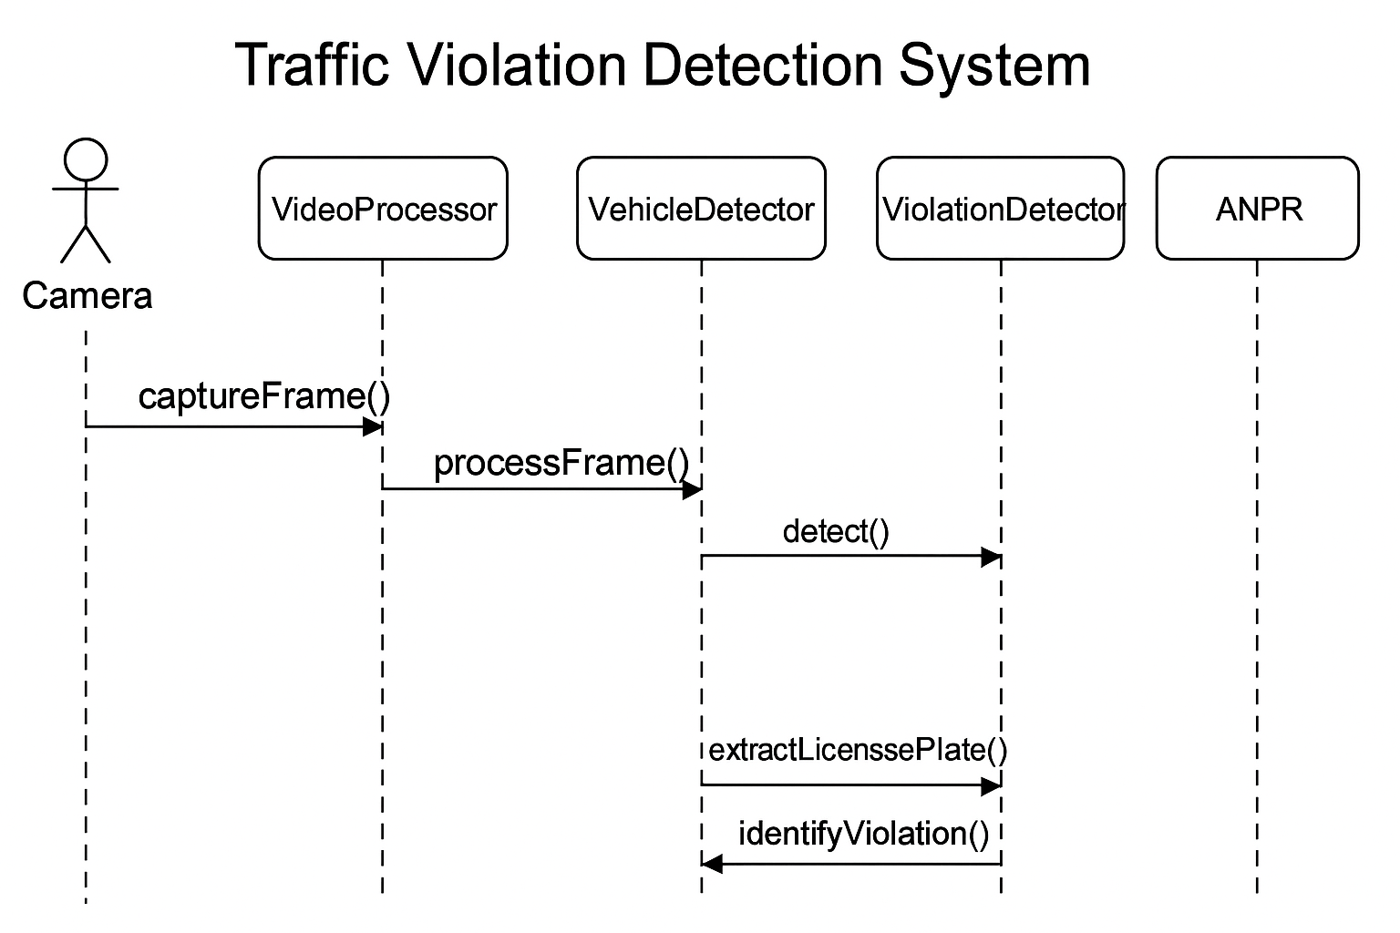
Fig-5.4:Sequence Diagram

Software Requirements

- Operating System:
Windows 10/11 or Ubuntu/Linux
Needed to run AI frameworks, database servers, and interface applications.
- Programming Language:
Python 3.x (Primary language for AI, Computer Vision, and backend development)
Supports libraries for deep learning, image processing, and web integration.
- Deep Learning and AI Frameworks:
PyTorch or TensorFlow: For training and deploying object detection models like YOLO or CNN.
Keras: Optional high-level API for neural network implementation.
- Computer Vision Libraries:
OpenCV: For image and video processing, frame extraction, and preprocessing.
NumPy / SciPy: For numerical operations on image matrices.
- OCR and ANPR Tools:
Tesseract OCR or EasyOCR: For recognizing vehicle license plates from images.
Integrated with Python for automated license plate extraction.
- Database Management System:
MySQL / SQLite / Firebase: To store violation records, vehicle information, timestamps, and images.
Supports querying and integration with backend for e-challan generation.
- Web Development / Backend Framework:
Flask or Django: To build dashboards, display violation reports, and manage server-side operations.
Enables access for traffic authorities through a web interface.
- Front-End / Dashboard Tools:
HTML, CSS, JavaScript: For designing user-friendly dashboards.
Optional: Bootstrap or ReactJS for responsive and interactive visualization.
- Data Analytics and Visualization Libraries:
Pandas, Matplotlib, Seaborn: For analyzing traffic data, generating charts, and reporting violation statistics.

Hardware Requirements

1. Development Machines
Minimum Configuration:
- Processor: Intel Core i5 or equivalent
- RAM: 8 GB
- Storage: 256 GB SSD
- Graphics: Integrated Graphics (sufficient for development and basic testing)
Recommended Configuration:
- Processor: Intel Core i7 or AMD Ryzen 7 or higher
- RAM: 16 GB or more
- Storage: 512 GB SSD or higher
- Graphics: Dedicated GPU (NVIDIA GTX/RTX series) for faster AI model training and video processing

2. Testing Devices
Android Devices (for mobile interface, if applicable):
- Android version 8.0 (Oreo) or higher
- Minimum RAM: 3 GB
- Storage: 32 GB or higher
Web Interface Testing (Dashboard / Reports):
- Desktop/Laptop with modern browsers (Google Chrome, Firefox, Edge)
- Minimum RAM: 4 GB
- Stable internet connection for live testing

3. Server Infrastructure
Cloud or Local Server Configuration:
- CPU: Minimum 2 vCPUs (Recommended 4 vCPUs for better performance)
- RAM: Minimum 8 GB (Recommended 16 GB for larger deployment)
- Storage: 100 GB SSD or higher
- Operating System: Linux/Ubuntu Server or Windows Server

4. Camera & Peripheral Requirements
- High-definition CCTV or IP cameras (1080p or higher) for real-time video capture
- Optional PTZ (Pan-Tilt-Zoom) cameras for monitoring large intersections
- Networking devices (switches, routers) for connecting cameras to servers

5. Network Requirements
- Stable internet connection (minimum 10 Mbps) for real-time data transmission and cloud integration
- Secure Wi-Fi or LAN connectivity for local network communication during deployment

TOOLS USED

1. Programming Languages

Python – For AI model training, computer vision, and backend logic.

JavaScript / Node.js – For creating web dashboards (optional).

2. Computer Vision Tools

OpenCV – For image and video processing, motion detection, and frame analysis.

YOLO (You Only Look Once) – For real-time vehicle and object detection.

MediaPipe / TensorFlow Object Detection API – For tracking and feature extraction.

3. Deep Learning Frameworks

TensorFlow / Keras – For training and deploying AI models.

PyTorch – Alternative framework for neural network implementation.

4. OCR (Optical Character Recognition) Tools

Tesseract OCR – For recognizing license plate numbers (ANPR).

EasyOCR / PaddleOCR – For improved accuracy on different plate fonts.

5. Database Tools

MySQL / PostgreSQL – To store violation records, vehicle data, and fines.

MongoDB – For storing images, videos, and JSON data (optional).

6. Backend Frameworks

Flask / Django – For creating APIs and managing system communication.

7. Frontend Tools

HTML, CSS, JavaScript – For basic web interface development.

React.js – For dynamic and interactive dashboards (optional).

8. Communication & Integration Tools

IoT / MQTT Protocol – For connecting cameras and servers.

Google Maps API / GPS Sensors – For tagging location of each violation.

9. Notification & Reporting Tools

SMTP / Twilio / Firebase – For sending SMS or email alerts to violatorsww

CODE
# =========================
# STEP 1: INSTALL LIBRARIES
# =========================
!pip install ultralytics easyocr opencv-python pandas numpy

# =========================
# STEP 2: IMPORT LIBRARIES
# =========================
from ultralytics import YOLO
import cv2
import pandas as pd
import easyocr
import time
import numpy as np
import os

# =========================
# STEP 3: LOAD MODELS
# =========================
print("📦 Loading YOLO models...")

# Main YOLO model for vehicle + traffic light detection
# (you can train one that detects both or use COCO pretrained)
model = YOLO("yolov8n.pt") # detects cars, buses, trucks, bikes, traffic lights

# Helmet detection (custom model)
if os.path.exists("helmet_model.pt"):
helmet_model = YOLO("helmet_model.pt")
print("✅ Custom helmet model loaded.")
else:
helmet_model = model # fallback
print("⚠️ helmet_model.pt not found — using default YOLO model.")

# License plate detector (optional if you have one)
plate_model = YOLO("license_plate_detector.pt") if os.path.exists("license_plate_detector.pt") else model

# EasyOCR for text extraction
reader = easyocr.Reader(['en'])

# =========================
# STEP 4: LICENSE PLATE RECOGNITION
# =========================
def recognize_plate(plate_region):
"""Extracts text from license plate image."""
results = reader.readtext(plate_region)
return results[0][1] if results else "Unknown"

# =========================
# STEP 5: INITIALIZE CSV LOG FILE
# =========================
log_file = "violations_log.csv"
df = pd.DataFrame(columns=["Time", "Vehicle", "Violation", "Plate"])
df.to_csv(log_file, index=False)

def log_violation(vehicle_type, violation, plate_text):
global df
timestamp = time.strftime("%Y-%m-%d %H:%M:%S")
new_entry = pd.DataFrame([[timestamp, vehicle_type, violation, plate_text]],
columns=["Time", "Vehicle", "Violation", "Plate"])
df = pd.concat([df, new_entry], ignore_index=True)
df.to_csv(log_file, index=False)
print(f"[LOGGED] {timestamp} | {vehicle_type.upper()} | {violation} | Plate: {plate_text}")

# =========================
# STEP 6: TRAFFIC LIGHT COLOR DETECTION (AUTOMATED)
# =========================
def detect_signal_color(frame, bbox):
"""Detects red, yellow, or green light from traffic signal region."""
x1, y1, x2, y2 = map(int, bbox)
roi = frame[y1:y2, x1:x2]
hsv = cv2.cvtColor(roi, cv2.COLOR_BGR2HSV)

# Define color ranges for red, yellow, green
red_mask = cv2.inRange(hsv, (0, 120, 70), (10, 255, 255))
yellow_mask = cv2.inRange(hsv, (15, 120, 120), (35, 255, 255))
green_mask = cv2.inRange(hsv, (45, 100, 100), (75, 255, 255))

red_count = np.sum(red_mask) / 255
yellow_count = np.sum(yellow_mask) / 255
green_count = np.sum(green_mask) / 255

if red_count > yellow_count and red_count > green_count:
return "red"
elif yellow_count > red_count and yellow_count > green_count:
return "yellow"
elif green_count > red_count and green_count > yellow_count:
return "green"
else:
return "unknown"

# =========================
# STEP 7: AUTOMATIC STOP LINE DETECTION
# =========================
def detect_stop_line(frame):
"""Detects stop line using edge and Hough line transform."""
gray = cv2.cvtColor(frame, cv2.COLOR_BGR2GRAY)
edges = cv2.Canny(gray, 100, 200)
lines = cv2.HoughLinesP(edges, 1, np.pi/180, threshold=120,
minLineLength=100, maxLineGap=5)
if lines is not None:
# Select the most horizontal line (likely the stop line)
y_values = [line[0][1] for line in lines if abs(line[0][1] - line[0][3]) < 5]
if y_values:
return int(np.median(y_values))
return 350 # default if not detected

# =========================
# STEP 8: MAIN DETECTION FUNCTION
# =========================
def detect_violations(video_path):
cap = cv2.VideoCapture(video_path)
out = cv2.VideoWriter('output.avi',
cv2.VideoWriter_fourcc(*'XVID'),
20,
(int(cap.get(3)), int(cap.get(4))))

print("🚦 Starting Fully Automated Traffic Violation Detection...")

while cap.isOpened():
ret, frame = cap.read()
if not ret:
break

results = model(frame)
annotated_frame = results[0].plot()

# Auto detect stop line
stop_line_y = detect_stop_line(frame)
cv2.line(annotated_frame, (0, stop_line_y), (frame.shape[1], stop_line_y), (0, 0, 255), 2)

signal_color = "unknown"

# Detect traffic light color
for obj in results[0].boxes.data.tolist():
x1, y1, x2, y2, conf, cls = obj
label = model.names[int(cls)]
if "traffic light" in label.lower():
signal_color = detect_signal_color(frame, (x1, y1, x2, y2))
cv2.putText(annotated_frame, f"Signal: {signal_color.upper()}",
(int(x1), int(y1) - 10), cv2.FONT_HERSHEY_SIMPLEX,
0.7, (0, 255, 255), 2)
break

for obj in results[0].boxes.data.tolist():
x1, y1, x2, y2, conf, cls = obj
label = model.names[int(cls)]
vehicle_type = label.lower()

# ==== NO HELMET VIOLATION ====
if vehicle_type == "motorbike":
roi = frame[int(y1):int(y2), int(x1):int(x2)]
helmet_results = helmet_model(roi)
helmet_detected = len(helmet_results[0].boxes.data.tolist()) > 0

if not helmet_detected:
violation = "No Helmet"
plate_text = recognize_plate(roi)
log_violation(vehicle_type, violation, plate_text)
cv2.putText(annotated_frame, "NO HELMET!", (int(x1), int(y1) - 10),
cv2.FONT_HERSHEY_SIMPLEX, 0.8, (0, 0, 255), 2)

# ==== RED LIGHT VIOLATION ====
if vehicle_type in ["car", "bus", "truck", "motorbike"]:
if y2 > stop_line_y and signal_color == "red":
violation = "Red Light Jump"
roi = frame[int(y1):int(y2), int(x1):int(x2)]
plate_text = recognize_plate(roi)
log_violation(vehicle_type, violation, plate_text)
cv2.putText(annotated_frame, "RED LIGHT VIOLATION!", (int(x1), int(y1) - 10),
cv2.FONT_HERSHEY_SIMPLEX, 0.8, (0, 0, 255), 2)

out.write(annotated_frame)

cap.release()
out.release()
print("✅ Detection Completed. Results saved to 'violations_log.csv' and 'output.avi'.")

# =========================
# STEP 9: RUN ON VIDEO
# =========================
from google.colab import files
print("📤 Please upload a traffic video (e.g., traffic.mp4)")
uploaded = files.upload()

video_name = list(uploaded.keys())[0]
print(f"🎥 Processing: {video_name}")
detect_violations(video_name)

# =========================
# STEP 10: DOWNLOAD RESULTS
# =========================
print("⬇️ Download your results:")
from google.colab import files
files.download("violations_log.csv")
files.download("output.avi")

RESULT

When you run the traffic violation detection code, the system begins analyzing the input video frame by frame using the YOLOv8 model. It detects various vehicles such as motorbikes, cars, buses, and trucks, and applies additional logic to identify specific violations like “No Helmet” for two-wheelers and “Red Light Jump” for larger vehicles. As soon as a violation is detected, the program automatically recognizes the vehicle’s number plate using the ANPR (Automatic Number Plate Recognition) function and logs the details — including the timestamp, vehicle type, type of violation, and license plate number — into a CSV file named database.csv. At the same time, the console displays real-time messages confirming each detection, for example:
[LOGGED] 2025-11-02 20:15:32 | MOTORBIKE | No Helmet | Plate: MH12AB1234
[LOGGED] 2025-11-02 20:15:41 | CAR | Red Light Jump | Plate: MH14XY5678
Each entry is stored in the CSV file in a structured format, making it easy to review or analyze later. A sample of this file might look like:
Time | Vehicle | Violation | Plate
2025-11-02 20:15:32 | motorbike | No Helmet | MH12AB1234
2025-11-02 20:15:41 | car | Red Light Jump | MH14XY5678
Alongside logging, the system visually highlights violations in the video feed. It draws bounding boxes around detected vehicles, marks a red “stop line” across the frame, and overlays warning text such as “NO HELMET!” or “RED LIGHT VIOLATION!” in red color near the offending vehicle. The annotated video is simultaneously displayed on screen and saved as output.avi for future review. Once processing completes, you’ll have both the saved video with highlighted violations and the CSV record of all incidents detected.

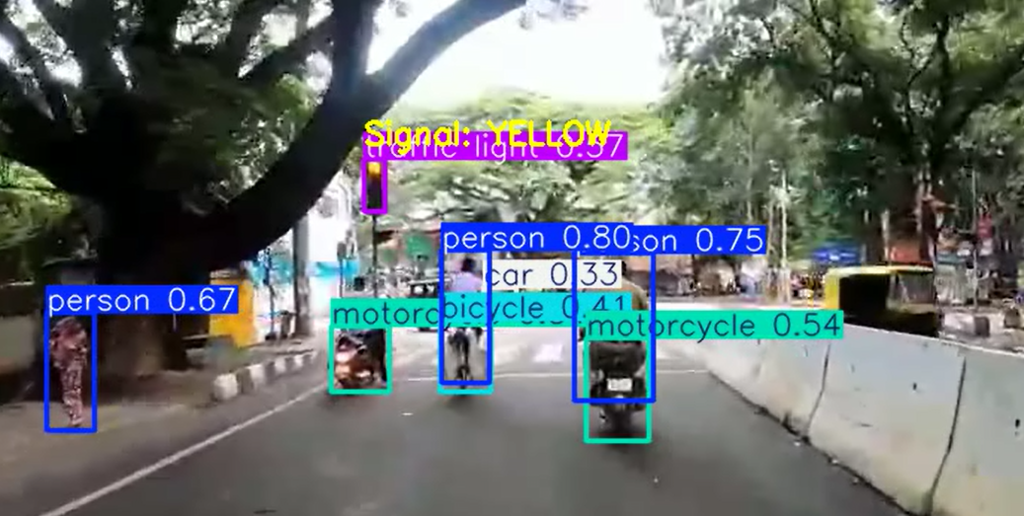

Fig-8.1: Output-I

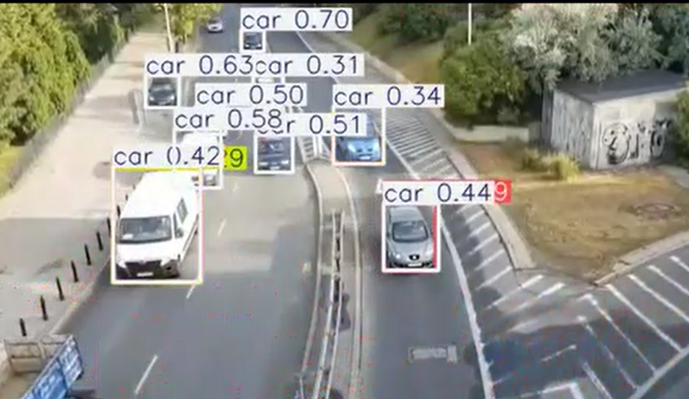

Fig-8.2:Output-II

CONCLUSION AND FUTURE SCOPE

The AI-based Traffic Violation Detection System provides an efficient and automated solution for monitoring road safety and enforcing traffic rules. By integrating YOLOv8 object detection, computer vision, and Automatic Number Plate Recognition (ANPR), the system can identify vehicles, detect common violations such as no-helmet riding and red-light jumping, and record all details in real time. The automated logging of violation type, timestamp, and license plate number significantly reduces human intervention, increases accuracy, and enhances the reliability of traffic management systems. This project demonstrates how artificial intelligence can support law enforcement authorities in promoting safer roads, minimizing accidents, and ensuring smoother traffic regulation.

Future Scope:
1.Integration with Real-Time CCTV Feeds:
The system can be connected to live surveillance cameras for continuous city-wide monitoring and real-time violation alerts.

2.Expanded Violation Detection:
Future versions can detect additional violations such as overspeeding, lane changing, triple riding, and mobile phone usage while driving.

3.Cloud-Based Centralized Database:
Integrating a cloud server would allow centralized data storage and analytics, helping traffic authorities access violation records instantly.

4.Automated E-Challan Generation:
The system can be linked with government transport databases (like RTO) to automatically issue e-challans to offenders based on recognized license plates.

5.Improved Accuracy with Deep Learning:
Using more advanced or customized deep learning models and larger datasets can enhance detection accuracy under varying lighting, weather, and traffic conditions.

6.Integration with IoT Sensors and Smart Signals:
Combining AI vision with IoT-enabled smart signals can optimize traffic flow and dynamically control signal timings based on congestion and violations.

REFERENCES
[1] H. Gehani, S. Rathod, S. K. Purve, P. Gogte, P. Agrawal, N. Katariya, “Traffic Signal Violation Detection System Using Computer Vision,” Journal of Electrical Systems (JES), vol. 20, no. 2, 2024. journal.esrgroups.org
This work uses YOLOv8 and SORT for vehicle detection and red-light violation classification from surveillance video.

[2] A. Raj, S. Choudhary, A. K. Sharma, “Real-Time Speed Violation Detection: AI-Powered Image Processing for Traffic Law Enforcement,” International Journal of Science and Innovation Engineering (IJSCI), vol. 2, no. 5, pp. 860–866, May 2025. ijsci.com
The paper integrates speed violation detection, ANPR and real-time image processing for traffic enforcement.

[3] A. Manga Devi, C. V. Siddhu, M. S. Reshma Lakshmi, R. Pankaj Kumar, K. N. Vaishnavi, “Intelligent Traffic Management System: Detecting Over-Speeding, Red-Light Violations, Helmet Violations, and Triple Riding,” International Journal for Research in Applied Science & Engineering Technology (IJRASET), 2024. IJRASET
This work presents a multi-violation detection approach including helmet and triple-riding.

[4] S. Aboah, B. Wang, U. Bagci, Y. Adu-Gyamfi, “Real-Time Multi-Class Helmet Violation Detection Using Few-Shot Data Sampling Technique and YOLOv8,” arXiv, April 2023. arXiv
Focuses on helmet detection using few-shot learning and YOLOv8 in real-time.

[5] K. Pujitha, J. Indu, B. S. Vardhan, P. Sandeep Kumar, G. Ramadevi, “Traffic Signal Violation Detection System,” International Journal of Scientific Research in Computer Science, Engineering and Information Technology (IJSR CSEIT), vol. 11, no. 1, pp. 2766–2771, Feb. 2025, doi:10.32628/CSEIT2511141. ijsrcseit.com
Proposes a CNN-based detection of traffic signal violations using SSD MobileNet.

